RSBuild Ver.1.0
Configuration Guide

Tuesday, September 13, 2005

Table of Contents
RSBuild Ver.1.0 Configuration Guide 1
Table of Contents 2
General Feature Information 3
Revision History 3
Introduction 4
How RSBuild Works 4
RSBuild Configuration Schema 4
RSBuild Configuration XML 5
Globals Section 5
ReportServer Section 6
DataSources Section 6
Reports Section 7
DBExecutions Section 7
Appendix A 8

General Feature Information

Revision History
Once this document has been released, all revisions are noted below.
Author | Date | Comments
Ting Huang | 10/03/2005 | Added report cache options support.

Introduction
RSBuild is a command line tool that can be used to process tasks, specifically Reporting Service build and deployment tasks, such as running database scripts or publishing shared data sources and reports to reporting service.

This configuration guide gives an introduction of how the RSBuild utility works and how you can make it to work for your project.

How RSBuild Works
RSBuild currently only supports two types of tasks: executing SQL Server scripts and publishing SQL Server Reporting Serivce reports and shared data sources.

It uses ADO.NET to execute database scripts in batch. Database script can be specified in the configuration file with specific database connection. (This tool can be extended to support other database provider)

To publish reports and data sources to SQL Server Reporting Services, it uses the generic web service interface provided by SQL Server Reporting Services. By specifying data sources and report files in the configuration file, it will publish them to the designated location on the report server.

Syntax:

RSBuild [config filename]

Arguments:

[config filename]: (Optional) Specifies which config file to be loaded. If this argument is omitted, RSBuild will default to load RSBuild.config in the same folder.

Examples:

The following command will run RSBuild with test.config
RSBuild test.config

The following command will run RSBuild with RSBuild.config
RSBuild

RSBuild Configuration Schema
(Description to be added)

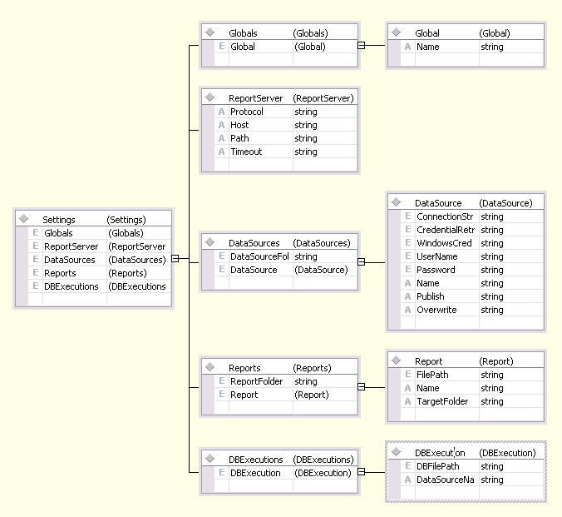

RSBuild Configuration XML
RSBuild configiguration XML defines tasks and resources for RSBuild utility to run. The config file contains of these sections: Globals, ReportServer, DataSources, Reports and DBExecutions.

<?xml version="1.0" encoding="utf-8"?>
<Settings>
<Globals />
<ReportServers />
<DataSources />
<Reports />
<DBExecutions />
</Settings>

Globals Section
Globals section defines a set of global variables. The name and value pairs of these variables can be used in RSBuild tasks.

<Globals>
<Global Name="ReportServer">localhost</Global>
<Global Name="ReportServerPath">ReportServer</Global>
</Globals>

For example, if the ReportServer variable is defined in the Globals, you can use ${ReportServer} wherever you want to reuse its value. For example, if you place ${ReportServer} in your database scripts and it will be replaced with the value in Globals at runtime when RSBuild executes.

ReportServers Section
ReportServers section defines the target report servers’ protocol, hostname, report path, etc. Note: you can specify multiple servers here.

<ReportServers>
<ReportServer Name="RS1" Protocol="http" Host="${ReportServer}" Path="${ReportServerPath}" Timeout="30" />
</ReportServers>

Element / Attribute | Data Type | Description
Name | String | Report server identity.
Protocol | String | The protocol which the report service is using. It should be either http or https .
Host | String | Host name of the report server.
Path | String | Virtual path the report server is using to serve requests.
Timeout | Integer  Default: 0 | Specifies the number of seconds that elapse before the connection to the server times out. A value of 0 specifies that the connection never times out.

DataSources Section
DataSources section defines data sources for various RSBuild tasks, e.g. executing database scripts, installing SQL Reporting Service report’s data sources, etc.

<DataSources>
<DataSource Name="Pageviews_reporting" Publish="true" Overwrite="false" TargetFolder="WMPortal" ReportServer="RS1">
<ConnectionString>data source=PPGMSCOMDEV04;initial catalog=Pageviews_reporting</ConnectionString>
<CredentialRetrieval>Store</CredentialRetrieval>
<WindowsCredentials>False</WindowsCredentials>
<UserName></UserName> <Password></Password>
</DataSource>
</DataSources>

For each DataSource:

Element / Attribute | Data Type | Description
Name | String | Name of the DataSource.
Publish | Boolean | Indicates if this DataSource will be published to report server.
Overwrite | Boolean | Indicates if this DataSource when published to report server will overwrite existing DataSource with the same name.
TargetFolder | String | The target folder where the data source will be published on report server.
ReportServer | String | The target report server where the data source will be published to.
ConnectionString | String | The connection string for a data source.
CredentialRetrieval | String  Default: Integrated | One of the Prompt / Store / Integrated / None values, indicating the way in which the report server retrieves data source credentials.
WindowsCredentials | Boolean  Default: True | Indicates whether the report server passes user-provided or stored credentials as Windows credentials when connecting to a data source.
UserName | String | The user name that the report server uses to connect to a data source.
Password | String | The password that the report server uses to connect to a data source.

Reports Section
Reports section contains a set of reports to be published to report server.

<Reports>
<ReportGroup Name="SearchCRDetail" DataSourceName="SearchCRRpting" TargetFolder="WMPortal/Detail/Search" ReportServer="RS1" CacheTime="10080">
<Report Name="Click-through by Search Term" CollapsedHeight="${CollapsedHeight}">
<FilePath>Detail\Search\Click-through by Search Term.rdl</FilePath>
</Report>
<Report Name="Click-through Summary" CacheTime="60">
<FilePath>Detail\Search\Click-through Summary.rdl</FilePath>
</Report>
</ReportGroup>
</Reports>

For each ReportGroup:

Element / Attribute | Data Type | Description
Name | String | Name of the ReportGroup.
DataSourceName | String | Name of the DataSource which all the reports under the ReportGroup will be using.
TargetFolder | String | The target folder where all the report under the ReportGroup will be installed under on report server.
ReportServer | String | The target report server where all the report under the ReportGroup will be published to.
CacheTime | Integer | The number of minutes that passes before a cached report expires. This setting applies to all reports in the current group if not otherwise specified by the Report. If not specified or specified using a number below zero, cache option will not be set.

For each Report:

Element / Attribute | Data Type | Description
Name | String | Name of the Report.
CollapsedHeight | String | When specified, RSBuild will try to modify the report’s body height using the given value. The value should be in unit of inches.
FilePath | String | The relative path to the .RDL file. (Relative to RSBuild.exe’s location)
CacheTime | Integer | The number of minutes that passes before a cached report expires. This setting can overwrite the CacheTime setting in ReportGroup. If not specified, the report will inherit the setting from ReportGroup. If specified using a number below zero, cache option will not be set.

DBExecutions Section
DBExecutions section defines database scripts to be executed against data sources.

<DBExecutions>
<DBExecution DataSourceName="MyWebMetrix_Integration">
<DBFilePath>SQL\MyWebMetrix\DBCleanup.sql</DBFilePath>
<DBFilePath>SQL\MyWebMetrix\Search.LOAD.sql</DBFilePath>
</DBExecution>
</DataSources>

For each DBExecution:

Element / Attribute | Data Type | Description
DataSourceName | String | Name of the DataSource which database scripts will be run against.
DBFilePath | String | The relative path to the database script file. (Relative to RSBuild.exe’s location)

Appendix A

Example of RSBuild.config.

[Please refer to the attached RSBuild.config file]

